British Values | Curriculum Key Concept | Trips/enrichment & visitors
Rule of Law, Democracy, Respect and Tolerance, Individual Liberty | Movement & People | Wingham Wildlife Park

Term 6 2023 Topic Title: Commotion in the Ocean
Key Concept Question: Why do we travel?
Core Text
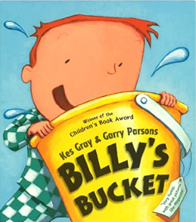

Billy only wants one thig for his birthday – a bucket!

Inside it he can see all kinds of magnificent sea creatures. But Mum and Dad are sceptical and, when Dad unwittingly uses the bucket to clean his car, he’s in for a BIG surprise!

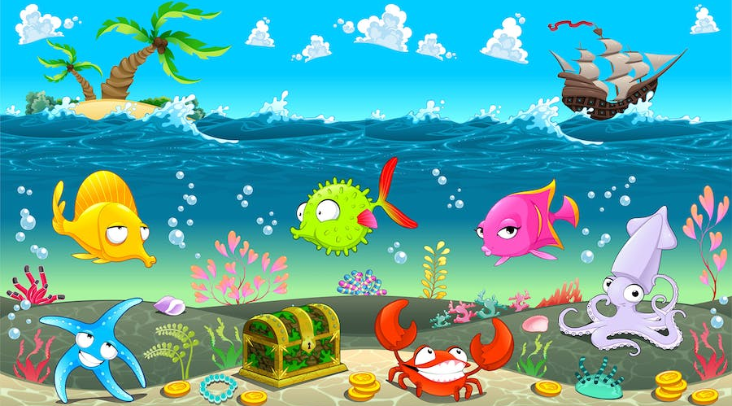
Personal, Social and Emotional Development
Why is my wellbeing important?
We will be learning why it is important to take care of our bodies through exercise and healthy eating and also why it is important to take care of our minds. We will learn about the importance of brushing our teeth and good oral hygiene too.
We will also learn about keeping safe in different situations such as crossing the road, or near water.
This term we will also prepare the children for the transition into year one.

Commotion in the Ocean
Communication and Language
What does that mean?
Our exploration of books; fiction and non-fiction In literacy will allow us to continue to expand our vocabulary. We will be able to talk about events in the past that shaped history; such as the discovery of dinosaurs and share ideas on what we can do to protect our oceans for the future. Children will share their experiences and ideas through speaking and listening times in show and tell and review time of their creative tasks.

Expressive Art and Design
How did they do that?
We will consider the most appropriate materials and methods to use as we analyse, evaluate and take inspiration the work of others. We will explore the work of Georgia O’Keefe and recreate her seashell work and the work of Katsushika Hokusai to make 3D wave collages. We shall also use clay to make our own fossil imprints too.
In music we will explore tuned and untuned instruments and make our own.
We will dance and move like different dinosaurs.

Literacy
What can we do to help?
The children will continue to explore both fiction and non-fiction books about the world, oceans and dinosaurs. We will create posters, factfiles, stories and letters using our phonics knowledge and understanding of writing to share our knowledge and what we can do to make a difference. We will write in sentences with a capital letter, finger spaces and a full stop. We will practise reading through our work to check it makes sense.

Understanding the World
What are fossils?
We will find out about Mary Anning and why her discoveries in the past are so important for what we know today about Dinosaurs.
We will use the story Someone Swallowed Stanley and explore the impact that pollution is having on our oceans. We will compare oceans around the world such as the Great Barrier Reef and begin to understand why it is protected.
We will continue to care for our sunflowers and eggs from last term.

Physical Development
How can I keep fit and healthy?
We will continue to focus on fitness activities, athletics and games. We will also prepare ourselves for our first Brabourne Sports Day.
We will continue to improve our fine motor skills through letter formation, and funky finger activities.

RE
Which Stories are Special and Why?
World Faiths
We will continue to share stories from the Jewish and Muslim faiths and understand why these stories are important. We will also look at the message these stories give and how this message is also given through Christian stories in the Bible.

Maths
We will follow the White Rose plans to continue to focus on numbers to 20 and explore counting and number patterns. We will double and halve numbers, share and group quantities and explore odds and evens.
We will continue to develop spatial reasoning skills by matching, rotating and manipulating shapes, including within patterns.
Outdoor Learning
We will use natural items to make our own paintbrushes and paint, create seeds, and make prints of leaves and petals onto calico.
We will explore shadows and create dinosaur shadow art.

Phonics
We will continue Level 4 phonics this term. We will be looking words with adjacent consonants and polysyllabic words and gain confidence in reading and writing them. We will continue to learn new tricky words and use the ones already learnt more freely in our writing. We will continue to write some phonetically decodable captions and sentences in our literacy work.

