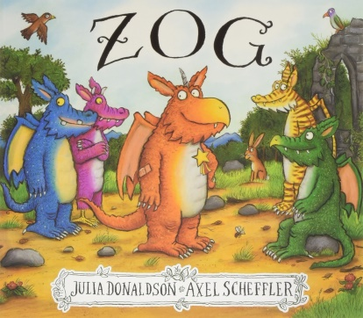b

**Understanding the World**

Make some dragon slime <https://www.learnwithplayathome.com/2013/08/cornflour-slime-how-to-make-and-what.html> Use your senses to explore it? Does its appearance change? Does its texture change? When? How? Make different colours and combine them. What happens?

Look at some pictures of knight’s armour and discuss what material you think was used to make the strong armour. Use magnets to explore metal items. What happens? What do you notice? Make a list of objects you find that are magnetic and non-magnetic.

**Maths**

Have a look at the White Rose Maths pack <https://whiterosemaths.com/homelearning/early-years/> (Summer Term Week 9)

Make your own set of dragon wings (see attached plan) and practise flying by jumping forward. Measure the distance you travelled in non-standard units – stones, sticks, footsteps etc.

Explore 2D and 3D shapes and make castles with them Encourage them to talk about the different shapes and sizes of the pieces they use and make links to the properties of the different shapes.

Build a tall tower or castle using building bricks or construction equipment you have and count the number of each colour of brick used. Discuss and explore ways of recording which bricks have been counted and the number of bricks used.

**Communication and Language**

Use a toy castle or cardboard box to introduce and discuss prepositions, such as ‘in’, ‘on top’, ‘behind’. Hide a toy dragon or one you have drawn in different positions such as in the castle, behind the castle and on top of the castle and describe where they are.

Try the ‘What Would You Include on Your Family Coat of Arms?’ activity (see attached) and encourage your child to talk about things that are important to them and their families and design coat of arms to represent them.

**Expressive Arts and Design**

Look at the different types of dragon in the story and compare their appearances. Design your own from clay or playdough. If you have used clay, paint it when it has dried. Think carefully about patterns and colours.

Ask an adult to help you make a dragon mask from a paper plate <https://www.youtube.com/watch?v=et36Al1C2dc>  
or a dragon from an egg box <https://nurturestore.co.uk/egg-box-dragon>

Watch the Dragon Dance form the Chinese New Year celebrations. <https://www.youtube.com/watch?v=3tqgPo5HVts>  
Use your dragon or mask and create your own dragon dance.

**Physical Development**

Try Joe Wicks PE everyday on Youtube at 9am or Jumpstart Jonny <https://www.jumpstartjonny.co.uk/>

Have races with your family. Talk about the positions you finish in. Use ordinal language to describe. Who finishes 1st, 2nd, 3rd etc. Try different types of races such as running, jumping, egg and spoon, obstacle, sack race etc.

Meet Cracker the Dragon in Cosmic Kids Yoga <https://www.youtube.com/watch?v=7NWzS2xziI4>

**Zog**

**Literacy**

Read “Zog” or watch it here <https://www.bbc.co.uk/iplayer/episode/b0bwdw8y/zog>   
Talk about the events in the story. What sort of character is Zog? What do the other dragons think of Zog? Why?

Look at the dragons and think of words to describe them. Can you put these words into interesting phrases. Eg. short spikey horns, green scaly skin. Explain these words are adjectives. Draw a dragon and label its features.

Your dragon has escaped. Use the descriptions you made to create a wanted poster.

Use the storyboard to plan a story about floating  
 away in a bubble.

**Personal, Emotional & Social Development**

Poor Zog. In the story he is unable to complete the challenges his teacher asks him. How do you think this makes him feel? Zog never gives up though. What does this tell us about his character? Can you think of a time when you didn’t give up? How did you feel in the end?

Talk about being brave – like knights. What does being brave mean? When were you brave? Remind them being brave means that they can still ask for help when needed but that they try new things and persevere with challenges. You could link this to the story of St George and the Dragon.

**Phonics**

We have now covered all of the phase 3 phonics sounds. Please recap all the sounds to ensure your child can recognise and write them.

Recap your phase 3 sounds by playing Dragons Den <https://www.phonicsplay.co.uk/resources/phase/2/dragons-den>

Try some of the outdoor phonics learning challenges. (see attached) How many can you complete?

Try the attached phonics writing prompt. Can you write about what you can see in sentences, using your phase 2 and 3 sounds correctly?