Bubbling Magic Potions
The Science Behind the Experiment – A Guide for Adults
Bicarbonate of soda is a chemical called sodium bicarbonate and is an alkali. Vinegar contains acetic acid. Mixing bicarbonate of soda and vinegar creates a reaction forming carbon dioxide which makes the bubbles and a residue of a
type of salty water.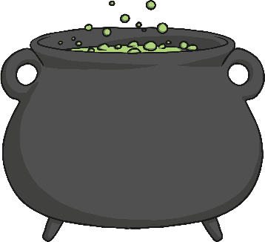
What happens when the ingredients are mixed together?
What can you see?
What words can you use to describe your potion?
What colours can you see?
Science Experiment
Bubbling Magic Potions

