**Literacy**

Before completing any of these topics, please take time to read or listen to the story ‘What the ladybird heard’ by Julia Donaldson. A reading of the story can be found at: -

<https://www.youtube.com/watch?v=XSbeEMfrkdw>

Then complete the following activities:

* Onomatopoeia is when a word describes a sound and actually copies the sound of the object eg: oink, me-ow etc. Find and list all the onomatopoeic words in the story.
* Watch the Lifecycle of a ladybird video clip (see science section) or find another clip/look in a book/internet to get ladybird facts. Then make a ladybird poster with your facts. This is a good place to start:

<https://www.natgeokids.com/uk/discover/animals/insects/ladybird-facts/>

* Write about The lifecycle of a ladybird. This is your title. Write a few sentences (Y1) about each stage. Year 2 should use subheadings Eggs/Larva/Pupa/Ladybird and write a few sentences/short paragraph about each section. Draw a picture of each stage.
* Write a repetitive poem called ‘What can you hear? Stand outside and listen. Write down what you hear using lots of description eg:

I can hear birds tweeting sweetly

I can hear a lawnmower cutting the fresh grass etc….

End the poem… What can **you** hear?

* Complete the ladybird comprehension sheets. Answer in full sentences. (see template)

NOTE: When asking children to write, the expectation is that Y1s should write simple sentences and try to use the conjunction “and” sometimes. The expectation for Y2 is that they use longer sentences with conjunctions such as “and’, “but”, “because” etc and use some adjectives. ALL children should be using capital letters at the start of a sentence and full stops (Y1) and exclamation marks (Y2) at the end of sentences.

**Science / Maths**

-Lifecycle of a ladybird. Watch the following short clip (Americans call the ladybug. Then complete the template.

<https://www.youtube.com/watch?v=9YMJyhYCI4s>

-Go on a bug hunt in your garden or around the park. Count how many insects you find and do a tally chart or pictogram

Play the doubles game before the worksheets: <https://www.topmarks.co.uk/Flash.aspx?f=dartboarddoublesandhalves>

-Ladybird Doubles Y1 (extend to doubles to 20 – use back of sheet)

-Doubled Dominoes Y2 (extend to doubles to 30 or beyond.

-Play dominoes with someone at home.

**Art/DT**

Draw and label a plan of your farmyard. Where would you put the horse? Or sheep? Or farmhouse?

You could also make a farmyard from old cardboard or Lego. You may have some little farmyard animals or could make some out of playdough.

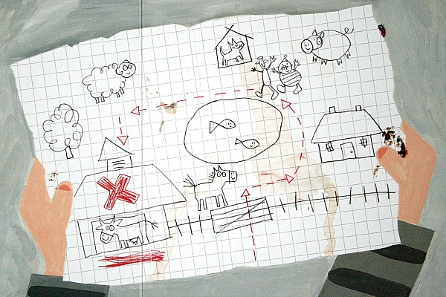

**French**



Practise counting to 10 or 20 in French .

Look at the clip:

<https://www.youtube.com/watch?v=UsEz58BblMY>

**RE**

One of our school values is **courage.**

The ladybird had alot of courage to speak out to help his fellow animals.

The bible story ‘Daniel and the lion’s den’ tells the courage of Daniel and his faith in God. Use a children’s bible or look at the clip to watch the story.

<https://www.youtube.com/watch?v=3KOjLRYSI3k>

Home Learning Topic Grid

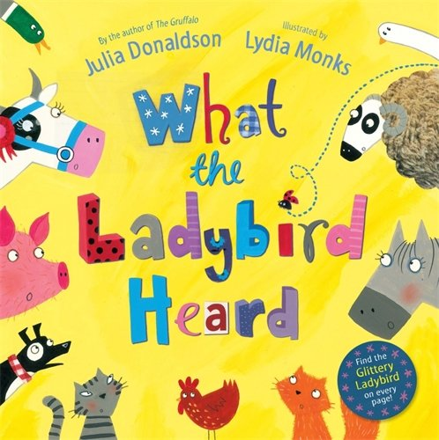

What the ladybird heard