**Literacy**

Before completing any of these topics, please take time to read or listen to the story ‘The Whale and the Snail” . A flim of the story can be found at: - <https://www.bbc.co.uk/iplayer/episode/m000cslw/the-snail-and-the-whale>

Then complete the following activities:

* Find all the words with the different /ai/ sounds which are a_e, ay, a and ai. Make a list in columns of all the words you can find. Which is the most commonly used sound? Which is least used?
* Find all the adjectives in the story. Make a poster of all the words you find
* A rock is described ‘as black as soot’. This is called a ‘similie’. Can you find any more in the book? Can you think of any of your own or find others in other books?
* Find all the rhyming words
* Choose a picture from the book and don’t look at the text. Write a postcard explaining your adventure in the scene as if you were the whale or the snail (see template)
* “If I were a snail, I would …..” Finish the sentence and write a small story (see template)
* Complete the snail comprehension sheets. Answer in full sentences.
* Make an acrostic poem or a poem of your choice about snails or whales (see template).

NOTE: When asking children to write, the expectation is that Y1s should write simple sentences and try to use the conjunction “and” sometimes. The expectation for Y2 is that they use longer sentences with conjunctions such as “and’, “but”, “because” etc and use some adjectives. ALL children should be using capital letters at the start of a sentence and full stops (Y1) and exclamation marks (Y2) at the end of sentences.

**Geography**

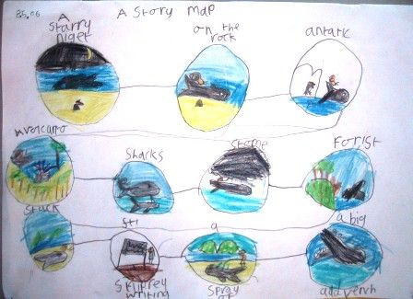

Think about where the snail and whale travelled. Draw a map that represents their travels. Think about directions they travelled, what Continents they travelled to and what landmarks they saw along the way.

Make a clay or playdough snail. Find a lovely big pebble outside for its shell and decorate it.

**Art/DT**

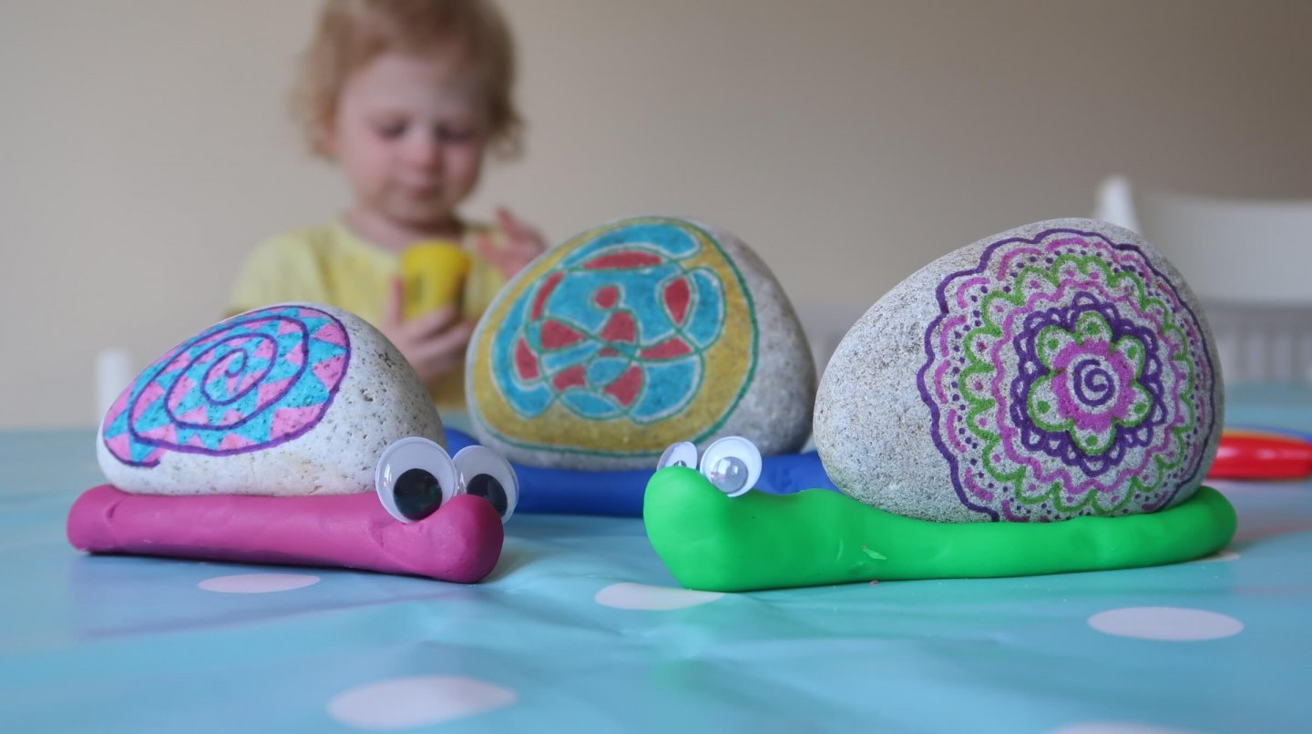

**PSHE**

Even though the snail is small, he helps save the whale. Think about your abilities. Is there anything that you couldn’t do, but you have managed to when you have tried? Draw a picture and write a small paragraph telling me all about it.

**Science / Maths**

Make your own snail slime by following this recipe. Think about the materials you have used and their qualities. Think about why you might need to add more of one of the ingredients.

<https://www.bbcgoodfood.com/howto/guide/how-make-slime>

Watch this video all about snails

<https://www.youtube.com/watch?v=c8ma6vDvXAM>

Go on a snail hunt in the garden. Observe the features of a snail and draw and label it. What are its characteristics? Where does it live? Complete the cut and stick worksheet and add some writing about what you have found out. Take some pictures of some snails you find.

Home Learning Topic Grid

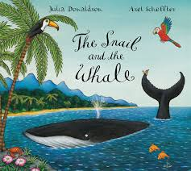

The Snail and the Whale