**Literacy**

Before completing any of these topics, please take time to read or listen to the story ‘Superworm’ by Julia Donaldson and illustrated by Axel Scheffler. A reading of the story can be found at:

<https://www.youtube.com/watch?v=7Jnk3XApKBg>

Then complete the following activities:

* Find the rhyme – find and write in pairs all the words that rhyme. Can you add any more rhyming words to your lists?
* Sentence work – Write out 10 sentences (or more) with facts about worms, eg:

A worm is a long, creeping animal.

A worm does not have legs.

* Keep practising phonics.

<https://www.phonicsplay.co.uk/resources/phase/3/dragons-den>

Y1 try phase 3, Y2 try phase 4

* Imagine you have Superworm as a pet. What amazing things could he do? Or be? Who does he save? Or does he need saving like in the story? Write a story about your Superworm. It should have lots of adjectives (describing words) and of course, a happy, hero ending. You could draw a picture of him at the end.
* If you could interview Superworm, what questions would you ask him. Write your questions and don’t forget to use ?
* Write an acrostic poem about worms.

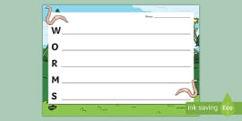

NOTE: When asking children to write, the expectation is that Y1s should write simple sentences and try to use the conjunction “and” sometimes. The expectation for Y2 is that they use longer sentences with conjunctions such as “and’, “but”, “because” etc and use some adjectives. ALL children should be using capital letters at the start of a sentence and full stops (Y1) and exclamation marks (Y2) at the end of sentences.

**Science / Maths**

Make your own mini wormery (see attached “how to make a wormery”). Have fun!

Y1 Cut out and order the ‘worms’ from shortest to longest. You could then measure them with a ruler in centimetres.

(see template)

Y2 Using a ruler and a sharp pencil, practise drawing different lengths in centimetres and millimetres. Which is your longest line? Shortest?

Extra work: Ask someone else to draw a straight line and see if you can measure it.

Addition and numberbonds challenge – Do 1 sheet (or challenge yourself to do more or all of the work sheets).See template.

Practise your mental maths

<https://www.topmarks.co.uk/maths-games/daily10>

Worms like it damp and dark but it is quite warm and sunny now. Keep a weather diary for the next 4 weeks (use template). If you have a thermometer, you could record the temperature. How many times does it rain?

**Geography**

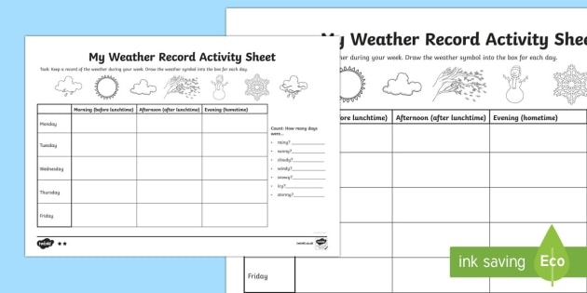

**Art/DT**

While you’re out in the garden or park, why not collect natural materials ( eg: petals, twigs, pebbles, grass) and make a collage. It could be a giant outdoor one or indoors on paper. Learn more about artists who work with nature such as Andy Goldsworthy or William Morris. Take a photo of your work and send it to school.

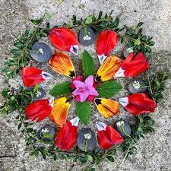

**RE**

Noah’s ark. Re-read / watch the story of Noah’s Ark from the Old Testament. Can you make a list of all the animals that went into the ark? Or play a game with someone taking it in turns to say an animal that went onto the ark. You could play it alphabetically eg: ant, bear, cat etc.

Do you think there were any worms?

<https://www.youtube.com/watch?v=gGAcaFfWmiQ>

Home Learning Topic Grid

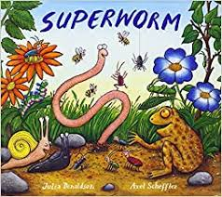

Superworm