**Literacy**

Before completing any of these topics, please take time to read or listen to the story ‘Room on the Broom’ by Julia Donaldson and illustrated by Axel Scheffler. A film of the story can be found at:

<https://www.bbc.co.uk/iplayer/episode/p0102qfj/room-on-the-broom>

Then complete the following activities:

* Find the rhyme – find and write in pairs all the words that rhyme. Can you add any more rhyming words to your lists? Complete the rhyming word activity (see template).
* Make your own Magic potion! What could you add? Could you use any natural items you’re your garden? Then write down your ingredients and method.(see template).
* Role play the story. Do you have a witch’s hat? A cat (real or fluffy) or a frog etc?

Can you remember and repeat the key lines from the story?

* Choose one of the animals from the story (cat, dog, bird,frog) and find out more about them eg: diet, habitat, amazing facts etc. Make a fact file on a piece of paper. Draw your chosen animals and write all about your chosen animal.
* Imagine you are flying up high on a broomstick. What would you see? Write a list and include lots of adjectives eg:

Flying high on my broomstick, I can see…

* large, green fields,
* tall, grey buildings that look like lego
* a blue river twisting and turning
* On squared paper, make your own wordsearch with words from the story.

NOTE: When asking children to write, the expectation is that Y1s should write simple sentences and try to use the conjunction “and” sometimes. The expectation for Y2 is that they use longer sentences with conjunctions such as “and’, “but”, “because” etc and use some adjectives. ALL children should be using capital letters at the start of a sentence and full stops (Y1) and exclamation marks (Y2) at the end of sentences.

**Geography**

Look at the different types of landscapes the witch flies over. Can you make a map of the journey she travels and the landscapes she sees? Can you find similar landscapes in your local area using a map or atlas of even when you go for a walk? Look at the powerpoint and see if you can spot any of the landscapes on your travels.

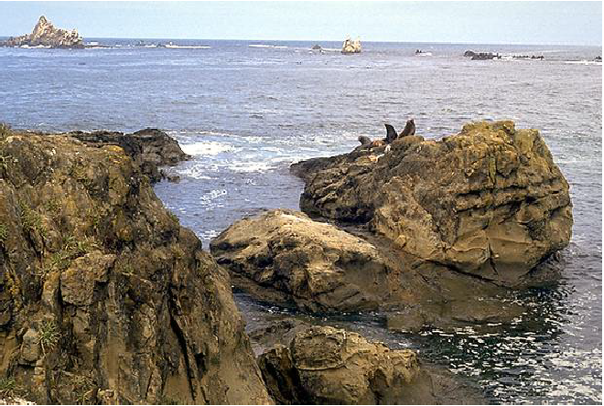

**Art/DT**

Design/make your own broomstick. What materials could you use? What could it have? Draw and label your diagram and then you could make it!

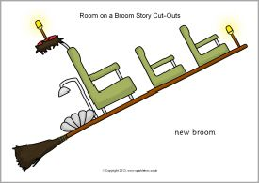

**PSHE**

The witch in the story is very kind as she invites all the animals onto her broom stick. Kindness is very important. If you had a magic broomstick, who would you invite aboard and why? Maybe you would choose your best friend, or your sister or your cat!

Can you still remember our 4 school values?

**Science / Maths**

Think back to your own magic potion… try this science experiment to make it bubble and fizz! (see template).

Capacity and volume – fill containers from your kitchen with water and discuss full/empty/half full etc. Will a tall thin container hold more/less than a short, wide one? Find out by experimenting.

Look at the packaging and look for the labelled capacity or volume in g/kg or ml/L. Try the measuring volume worksheet and write the amount of liquid in each container. You could then try to measure this out in your container. For extra work, see if you can count on to find out how much more liquid would be needed to fill the container. (see template)

Home Learning Topic Grid

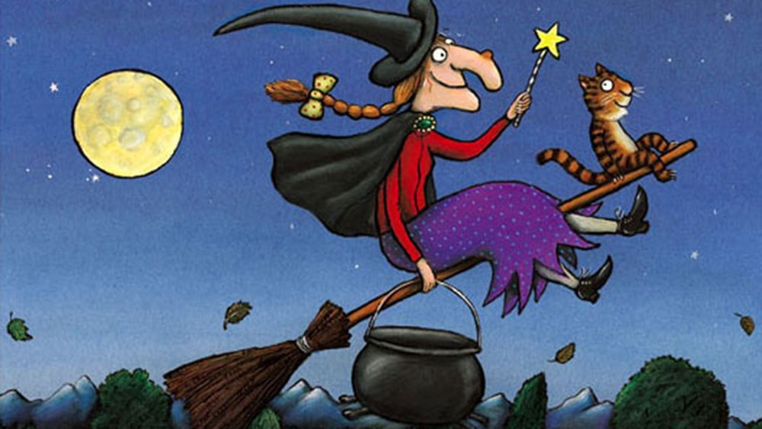

Room on the Broom