Year 2:

 



Literacy

Please make sure you read “The Enormous Crocodile” or watch the story on Youtube (see links in letter to parents).

1. Using the words and ideas from the story, brainstorm all the words that describe the crocodile and what his character is like, eg: sharp teeth like knives, greedy, horrid, etc.
2. Use your ideas above to create a “wanted” poster for the crocodile. Write in full sentences. You can use the attached template.
3. Using the attached template, write down each of the 4 tricks the crocodiles uses, cut up each part and stick together to make one enormous crocodile!
4. Write a character description of another character in the story other than the crocodile (chose one from the attachment). Use the words that best fit that character to help you write in full sentences.
5. Plan a new trick that the Enormous Crocodile could use to catch some children. Could you write a new page for the book that includes this trick? How might he/she be defeated by the other animals?
6. Draw a story map and plan your own version of the story with just maybe 1 or 2 tricks. This could be The Tiny Mouse, The Nervous Elephant or the Terrifying Tortoise! Think about what would happen at the beginning, middle and end. Draw pictures at each stage of your plan. Retell your own version of the story verbally to your family at home.
7. Use the stick puppet cut outs and perform the story to your family as a puppet show using different voices for different characters.
8. Complete the Rainforest Reading Comprehension sheet. 1 * (Year 1), 2 ** (Year 2) and 3 *** for Level 9 readers and above.

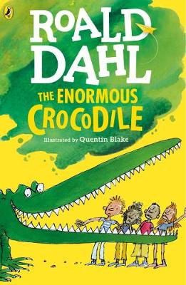

Year 1:





**Spellings – Common Exception Words**

Home Learning Grid

w/c 18th May and 1st June 2020

**Geography**

1. Research the animals that live in the Rainforest. There are some good videos on Youtube. With the knowledge you already know about the different layers of the Rainforest, complete the cut and stick activity sorting of which animals live in what layers. Can you think of any other reasons they live on this layer? Write your ideas down.

2. Talk to an adult in your house about what is happening to our Rainforests (deforestation) and why it is important to look after them. Design a poster to “Save the Rainforest”. Include a few facts and drawings.

3. Complete the Rainforest Reading Comprehension sheet. 1 * (Year 1), 2 ** (Year 2) and 3 *** for Level 9 readers and above.

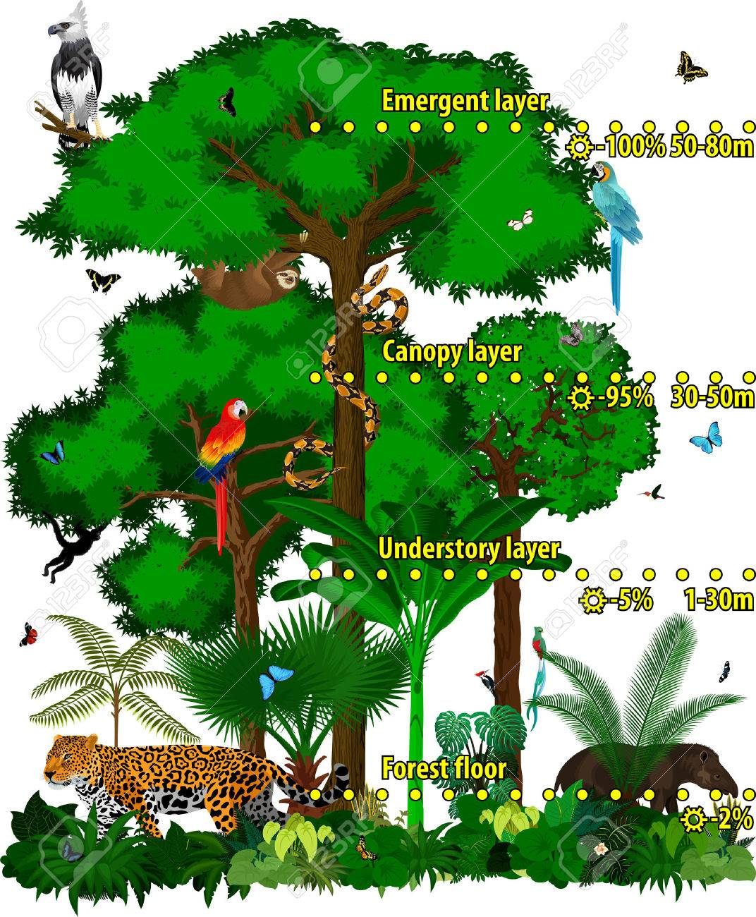 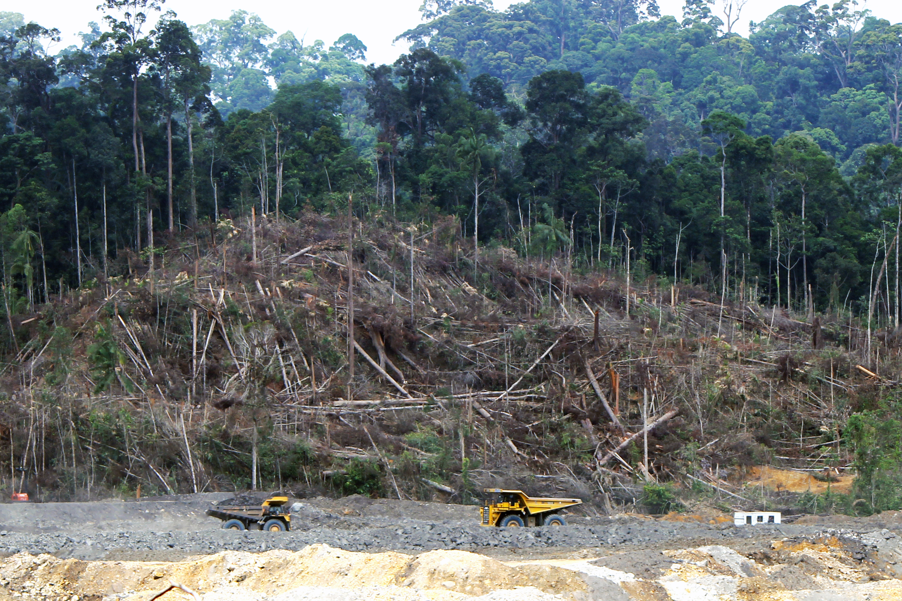

**Art / DT**

Choose 1 or more of the following activities using junk modelling and/or natural resources from outside:

1. Can you make a trap for the Enormous Crocodile? Think about a mechanism to make the trap close.

2. Can you make a model of one of the rides at the fair?

3. Can you make the enormous crocodiles of any junk modelling you have had home?

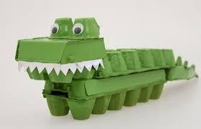 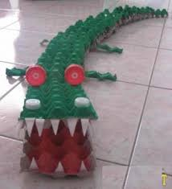

**Science**

When Trunky the Elephant swang the Enormous Crocodile into Space, he was using a force. What is a force? A force is something that makes an object move. There are lots of different forces; pushing, pulling and twisting being some of them. Watch this clip “Seymour Science”. <https://www.bbc.co.uk/bitesize/clips/z9nkqty> then complete the stick and cut activity sheet.

Now collect from your bedroom a selection of toys. What force do you use to make your toy move or work? Are you pushing, pulling or twisting? If you are not sure, look at the attached powerpoint to help you. Experiment making your toys move slower or faster.

Broader Curriculum