Simple Musical Instruments

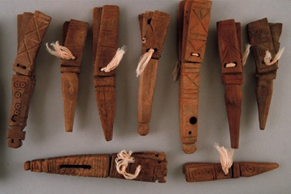
Clappers

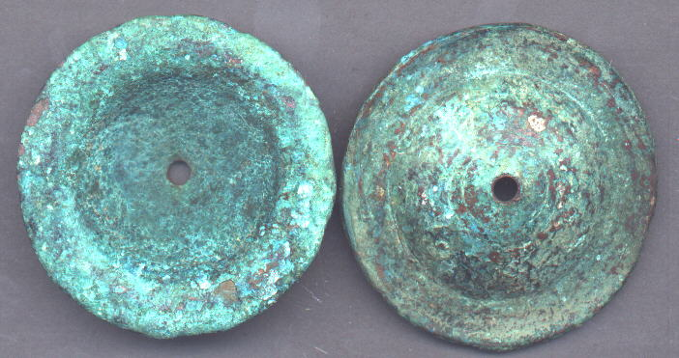
Cymbals

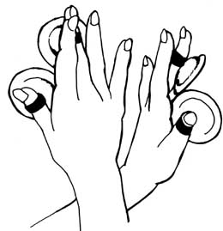
Technique for playing pairs of small cymbals

Hunting and fishing

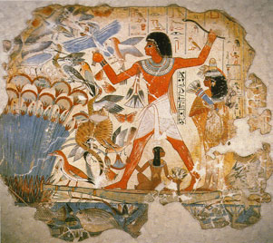

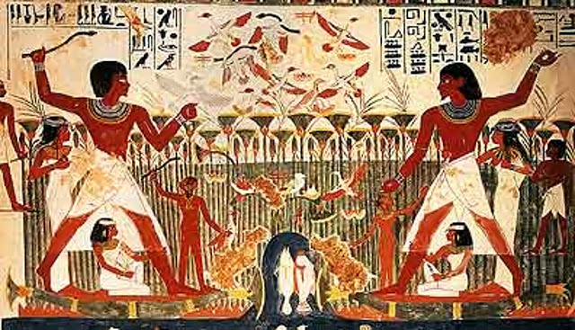

Find the fish, birds and hippopotamuses that are being hunted
Identify the papyrus plants

The hunter Nakht, in the second painting is shown twice with his family

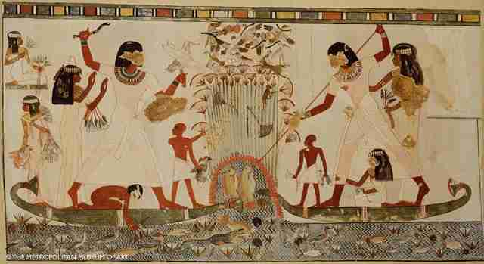
Hunting and fishing from boats made of papyrus reeds
Can you find the crocodile?

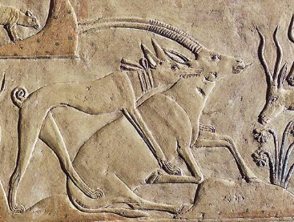
Hunting with a dog

Sports

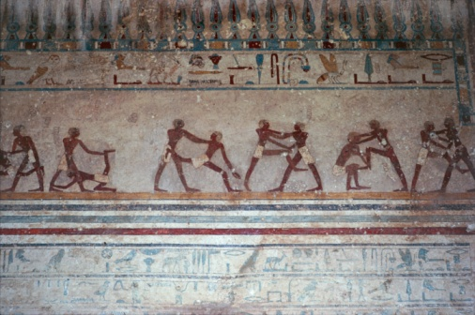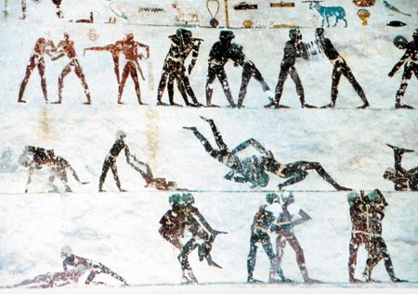
Wrestling

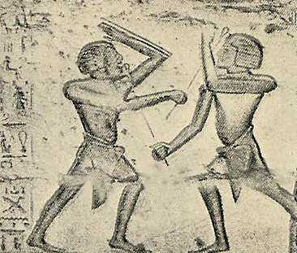
Fencing

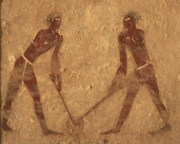
Hockey

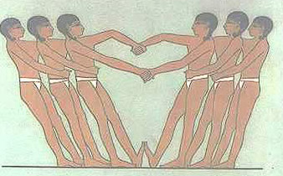
Tug of war

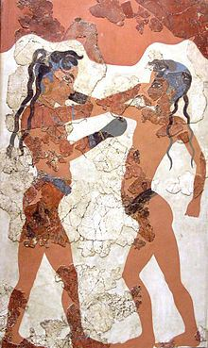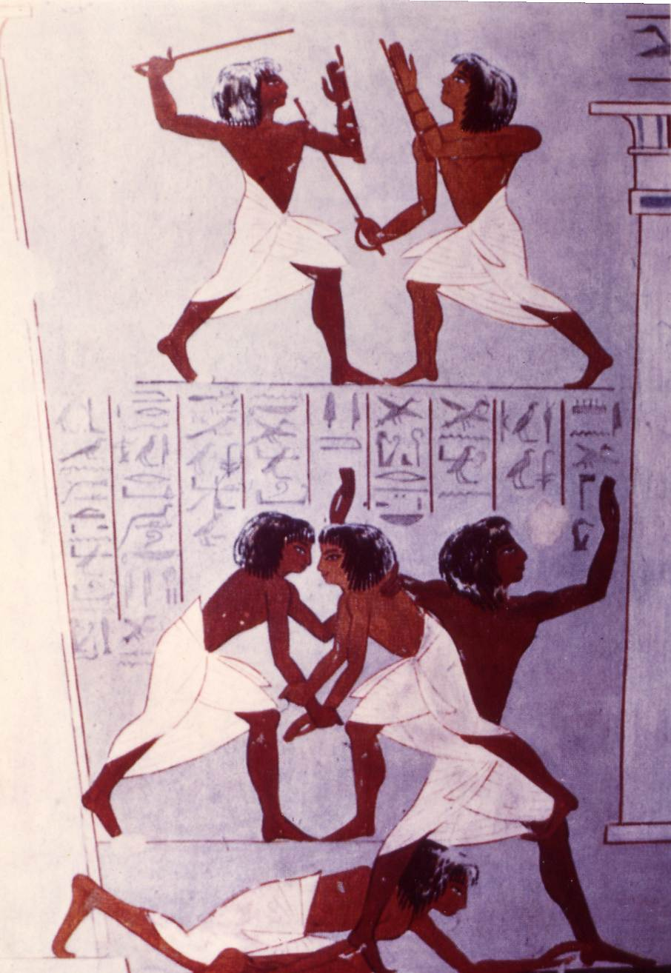
Boxing Fencing and wrestling

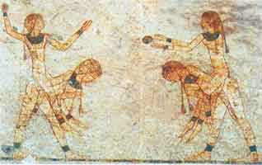
Ball game
How might it be played?

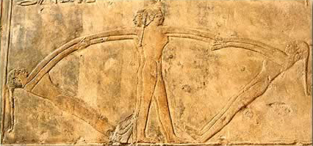
A dance, swinging game, balance game, or…
How would you interpret this game?

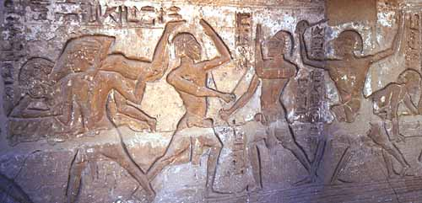
What can be seen in this relief?

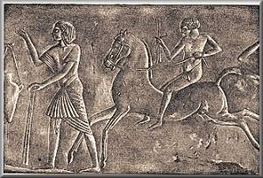
What does this image show?

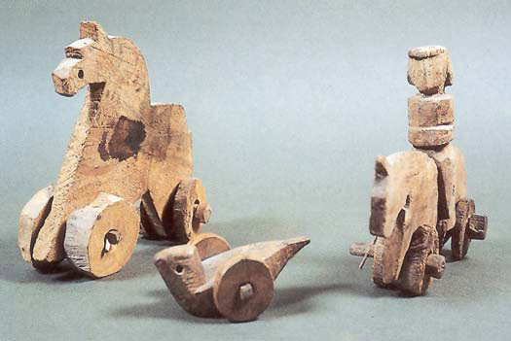
On wheels

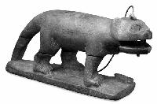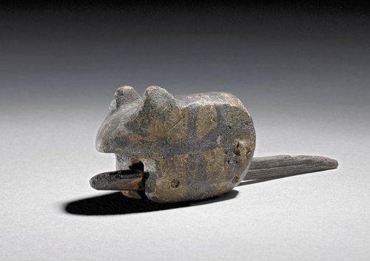
With a moving mouth – hippopotamus and cat

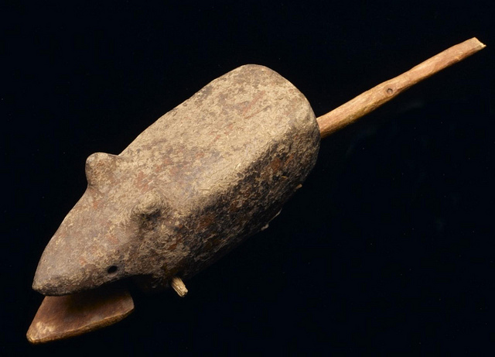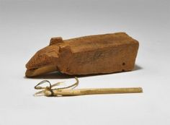
Mice

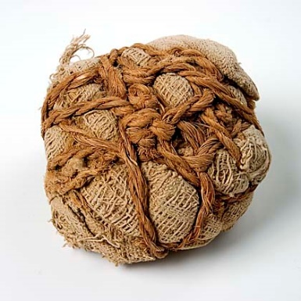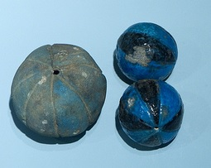
Balls

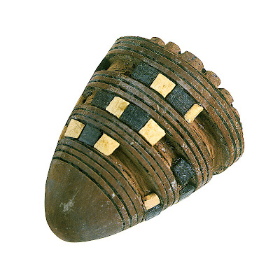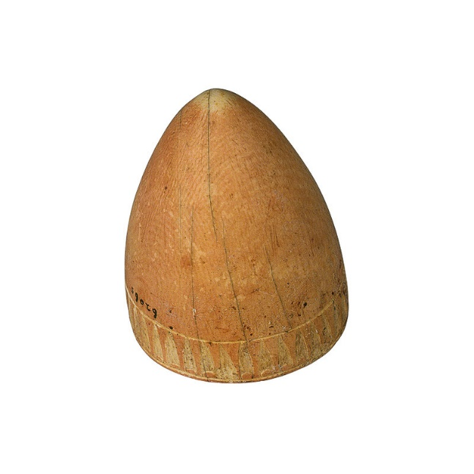
Spinning tops (first one from Tutankhamun’s tomb)

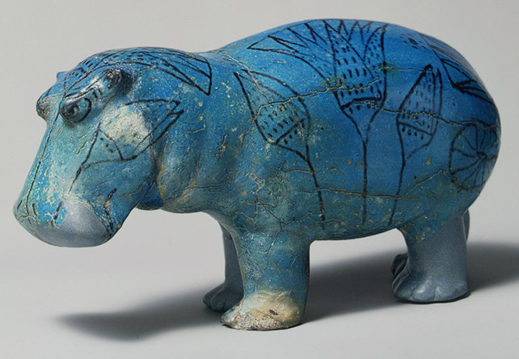
Ceramic hippopotamus

Dolls

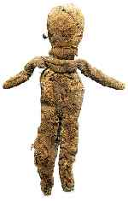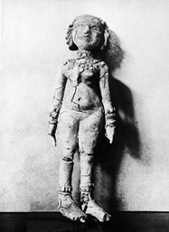
Rag doll stuffed with papyrus Clay doll

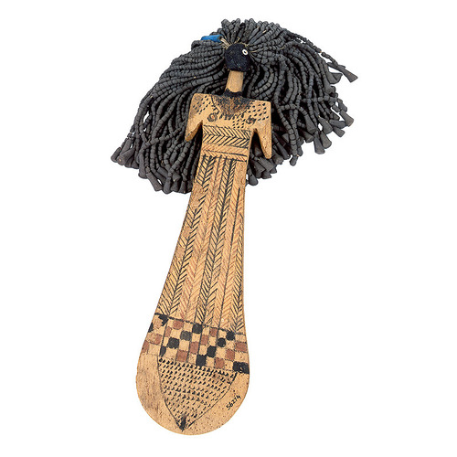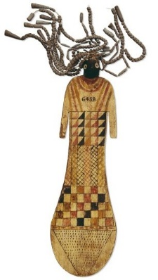
These wooden dolls with beaded hair may have been toys or symbols placed in tombs

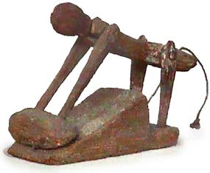
This doll ground grain when the string was pulled

Board Games

Board Games like Senet were popular in Ancient Egypt. Game pieces started as simple shapes like discs and cones but became more detailed and were sometimes carved into animal shapes. Dice carved from stone and ivory were typical components of many ancient Egypt games.

Hounds and Jackals, a board game a little like snakes and ladders! Archaeologists think it was played with five pieces per player, one using five hound shaped pieces, the other five jackal-like shaped pieces.

Mehen The game of the snake played on a one-legged table. The board was often carved with the design of a coiled snake which was divided up into squares. Like many other Ancient Egyptian games, the rules are unknown. Many sets have been found buried in tombs dating back to 2000BCE.

Marbles games are very ancient. A white and a black stone marble and three little stones forming an arch seem to have been used in a game which may have been played like a sort of mini-skittles.

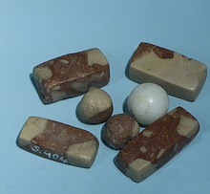

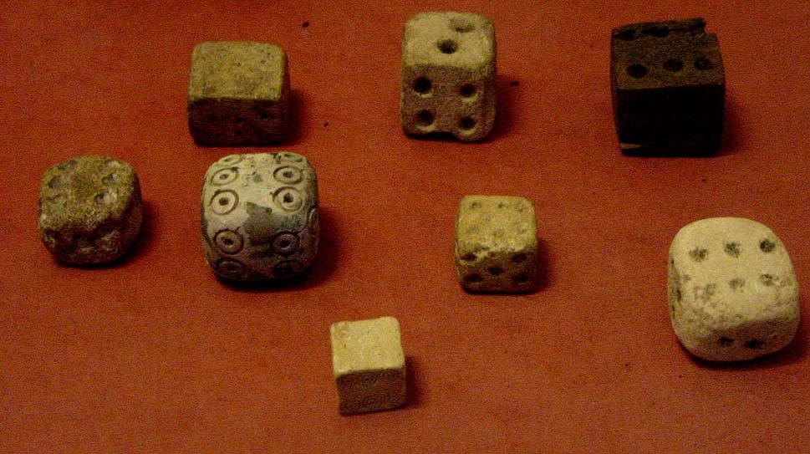
Egyptian dice

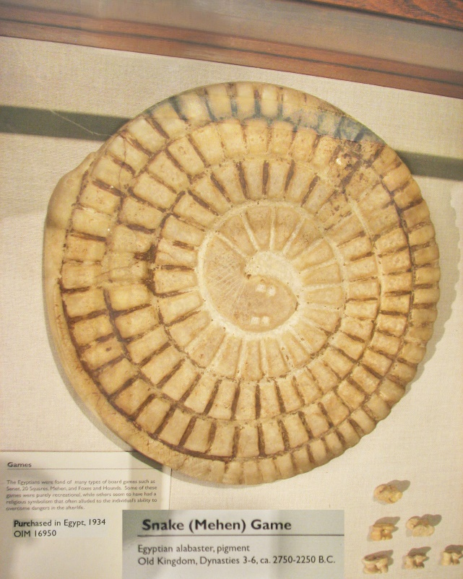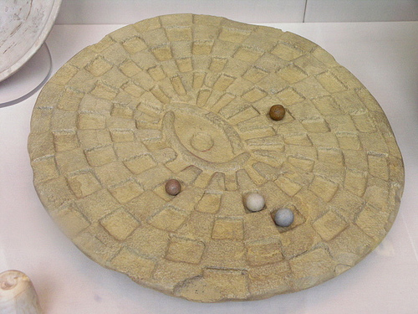
Mehen or Snake game

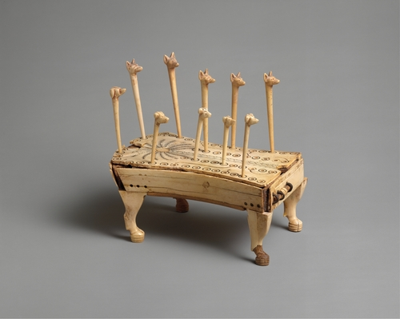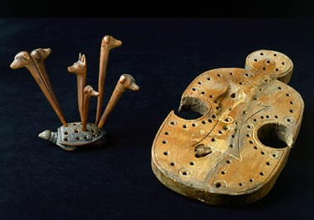
Hounds and jackals

Playing Senet

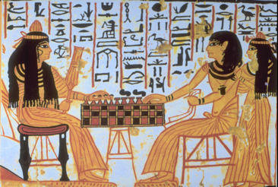

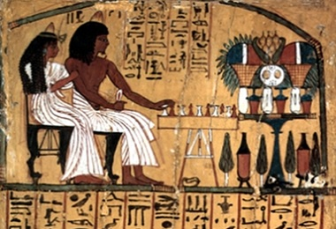

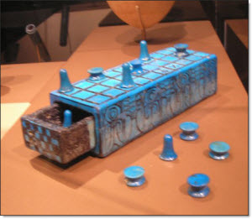

Instructions for Ancient Egyptian Game

Title:
What you will need: | Useful diagram:
Objective of the game:
How to play the game:

Spiral Template for Mehet Board
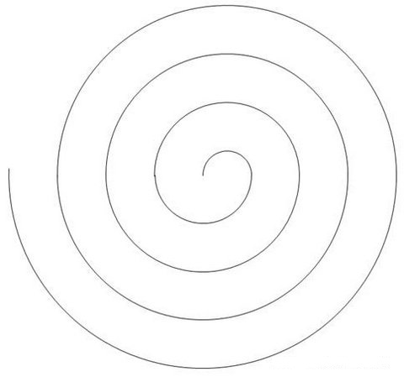
Senet Board

