RUCSAC Word Problems – Problem solving
LNF: Look for key words to find out what the text is about. Identify steps to complete the task or reach a solution . Select appropriate mathematics and techniques to use. Use checking strategies to decide if answers are reasonable.

Traffic Light

- Luke Sky Walker has 63 pod racers in his garage. In a race he wins 35 more pod racers. How many does he have altogether?
Read
Underline
Choose
Solve
Answer
Check

- A storm trooper is guarding 84 Jedi prisoners. When he isn’t looking, 32 of them break free and run away. How many Jedi are there now?

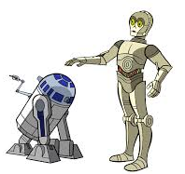
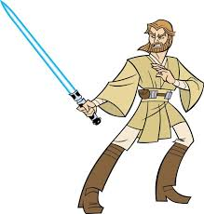
Read
Underline
Choose
Solve
Answer
Check

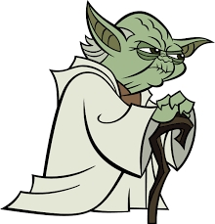
- 79 candles are lit in the Jedi Temple. Yoda blows 33 of them out. How many candles are left lit in the temple now?
Read
Underline
Choose
Solve
Answer
Check

- Anakin Skywalker has 48 blue lightsabers, 12 yellow lightsabers and 44 green lightsabers. How many lightsabers does he have altogether?

Read
Underline
Choose
Solve
Answer
Check

Assessment For Learning

I found question ______ the most difficult

because______________________________________________

____________________________________________________
I am confident using the RUCSAC method : yes/no (Highlight)

______%

