RUCSAC Word Problems – Problem solving
LNF: Look for key words to find out what the text is about. Identify steps to complete the task or reach a solution . Select appropriate mathematics and techniques to use. Use checking strategies to decide if answers are reasonable.

Traffic Light

- Luke Sky Walker has 2169 pod racers in his garage. In a race he wins 4125 more pod racers. How many does he have altogether?
Read
Underline
Choose
Solve
Answer
Check

- A storm trooper is guarding 284 Jedi prisoners. When he isn’t looking, 136 of them break free and run away. How many Jedi are there now?

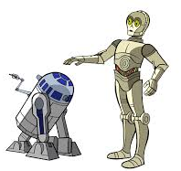
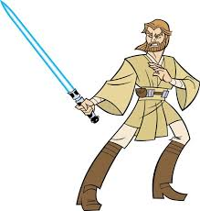
Read
Underline
Choose
Solve
Answer
Check

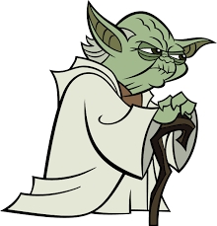
- 6279 candles are lit in the Jedi Temple. Yoda blows 2183 of them out. How many candles are left lit in the temple now?
Read
Underline
Choose
Solve
Answer
Check

- Anakin Skywalker has 248 blue lightsabers, 152 yellow lightsabers and 404 green lightsabers. How many lightsabers does he have altogether?

Read
Underline
Choose
Solve
Answer
Check

Assessment For Learning

I found question ______ the most difficult

because______________________________________________

____________________________________________________
I am confident using the RUCSAC method : yes/no (Highlight)

______%
Extension:

- Droids are bought in pairs (groups of 2). Darth Vader bough 28 pairs of droids. How many droids did he have altogether?

Read
Underline
Choose
Solve
Answer
Check

- _____________________________________________________________________________________________________________________

Read
Underline
Choose
Solve
Answer
Check

