Making a Food Web
You will need: A sheet of Food Web cards, a large sheet of paper in landscape orientation, a pencil, pen and glue stick each Work with your partner.
Choose either British sealife or wildlife. If you want you could do both. Look carefully at your 12 cards and cut them out.
• Find a producer (a living thing that makes its own food) and put this on the left hand side of your sheet of paper.
• Find a creature that eats your producer (a primary consumer), place this a little way to the right and draw a feint pencil arrow to connect them – remember the arrow shows the direction the energy is moving. Keep arrows feint to begin with because you may need to move things around a bit to make space.
• Now look for a creature that eats your primary consumer (a secondary consumer) and add this to your food chain with a feint arrow as before. If you can’t find one, try swapping your primary consumer for a different one that may give you a longer food chain.
• Now look for an animal that eats your secondary consumer - you may not be able to find one. If you do find one add this creature to your food chain.
• Discuss your food chain. What is the producer? Who is the top predator? Who is their prey? Is there more than one predator?
• Now try to add some more of the cards to make a food web – remember lots of different animals can eat the same food. Draw feint arrows to show which way the food energy is transferring. You may not be able to fit all your cards in but add as many as you can.
• Once you are happy with your food web you can begin to stick the cards down but first cut away the writing at the bottom (because your arrows explain what eats what!). Cut and stick one at a time so you don’t forget where they all go!
• Ink in the arrows with a pen.
• Add a title at the top (it needs to explain where your creatures live).
• At the bottom, write some sentences to explain who are the predators and prey, and who are the producers and consumers. Who are the top predators?
British Sealife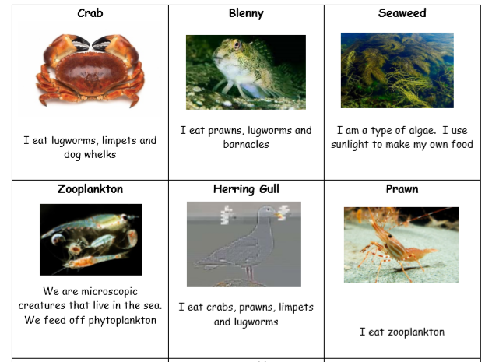
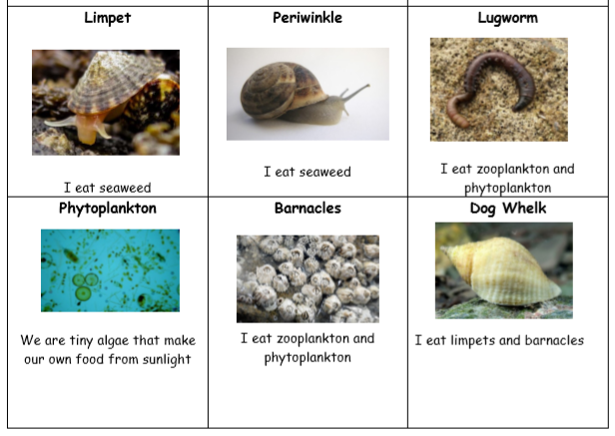
British Wildlife
