Papyrus

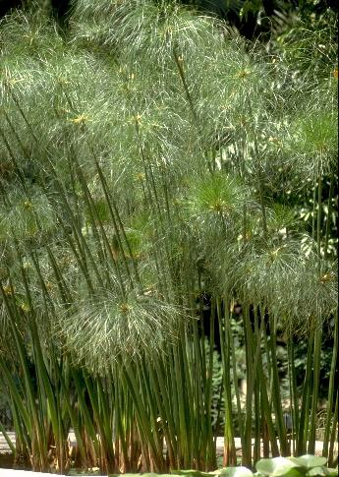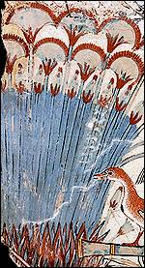

Papyrus growing Papyrus shown in an Ancient Egyptian painting

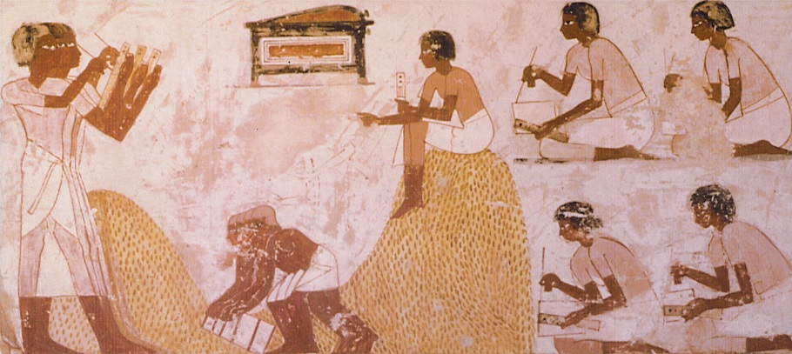

Can you see the writing palettes?

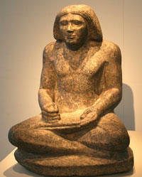

A scribe

Papyrus

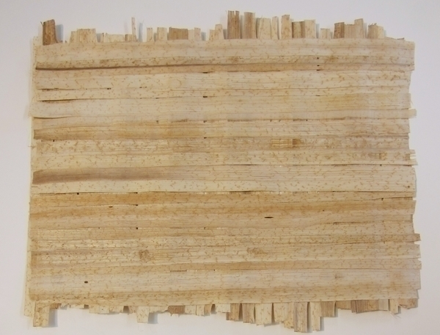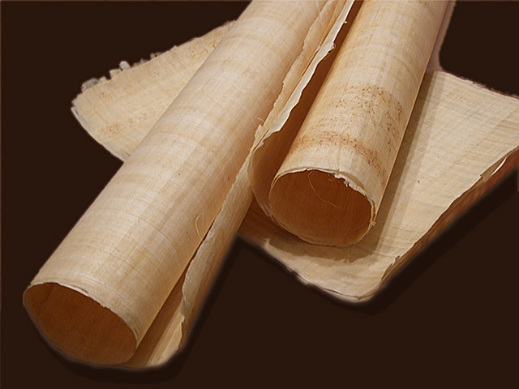

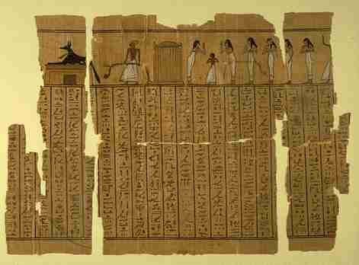

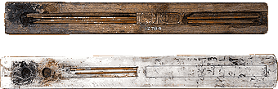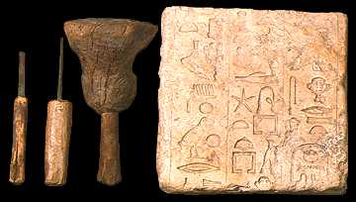

Scribe’s palettes Tools used for carving hieroglyphs

How Papyrus was made

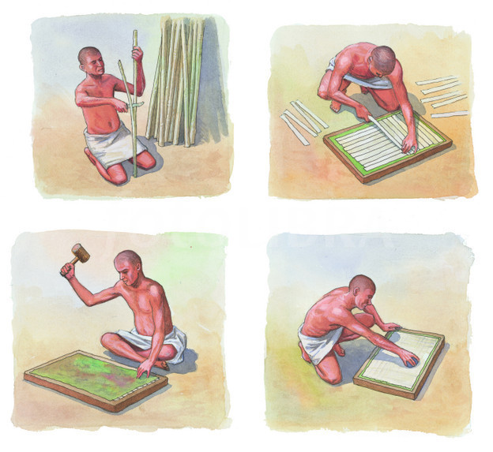
The outside layer of the stem was removed. The inner part of the stem was sliced into long strips and placed side by side with a second layer on top at a right angle. Then the whole thing was soaked in water and pressed under a heavy rock for many days. The juice of the plant acted like glue and bonded the strips together. The result was a sheet, which was hammered flat and dried in the sun. Once dry it was polished using a piece of wood or ivory. Papyrus was first made as early as 3100 BCE.
The Ancient Egyptians wrote with reed brushes dipped in ‘ink’ made from grinding coloured minerals and adding liquid. The ink was kept in two depressions in the scribe’s palette (one for black ink & one for red ink). The end of the thin reed used to write with was hammered soft which made it fray and it was then trimmed.

Have a go yourself.

There are two methods.
- You could make some ‘papyrus’ by laying out strips of paper side by side. Experience has taught me to make the strips about 1 - 2cm wide. Anything bigger and it is hard to weave and is too bulky to write on anything narrower and it all breaks apart. The length of the strip should be about 30cm so if you use one sheet of A4 that would be perfect. Carefully weave the strips into one another. This is tricky. Once that is done make the paper wet, if you have any PVA mix some with water and spread that over the surface. After a couple of days, it should be nice and dry, and you should be able to write on it.
- This alternative method is a bit easier. Get some A4 paper. Dip it in water with a tea bag or coffee. Don’t leave it in there too long or it all falls apart. Take the paper out and allow it to dry. Spread it somewhere flat when you do this otherwise it dries into all sorts of shapes. When it is dry then you should be able to write on it. If you wanted to have a scroll like effect, then simple roll it up and tie it with a piece of material or ribbon.

Here are some website to help you.
https://www.lib.umich.edu/papyrus_making/lg_gardens.html - Papyrus being made today; http://www.britishmuseum.org/channel/exhibitions/2011/book_of_the_dead/video_papyrus.aspx - Preparing a sheet of papyrus for an exhibition at British Museum;
https://www.youtube.com/watch?v=q0zlBUbcWWQ - Details of the Book of the Dead papyrus in British Museum;
http://www.childrensuniversity.manchester.ac.uk/learning-activities/history/ancient-egypt/the-egyptian-number-system/ or
http://www.gwydir.demon.co.uk/jo/numbers/egypt/intro.htm - AE numbers websites.

Week 2 Ancient Egyptian Numbers
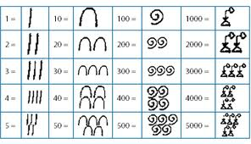
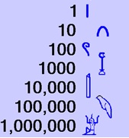

100 = coil of rope
1 000 = lotus or water lily plant
10 000 = man’s finger
100 000 = tadpole about to metamorphose into a froglet
1 000 000 = man/god with both hands raised

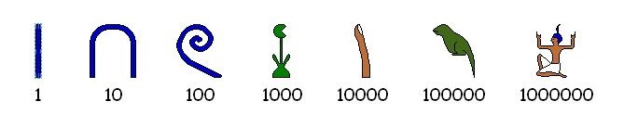

Ancient Egyptian Arithmetic
1, 10, 100, 1 000, 10 000, 100 000, 1 000 000

I love the final symbol it shows a scribe throwing his hands up in tired frustration having counted to 1 million. True, I learnt that in Egypt.

This is your week 2 work. Write these calculations out onto your papyrus. Write one out in English numerals and the other in Egyptian! I have put the answer at the bottom.

+ =

- =

x =

÷ =

+ =

- =

No peeking! Here are the answers.
124+1315=1439,
626-311=315,
32x4=32x2+32x2=64+64=128,
120÷2=60,
18562+ 32231=50793

& 165562-24213=141349.

