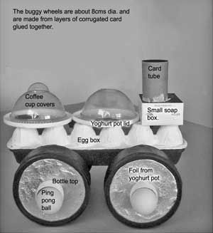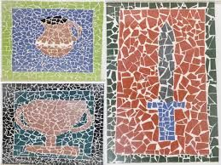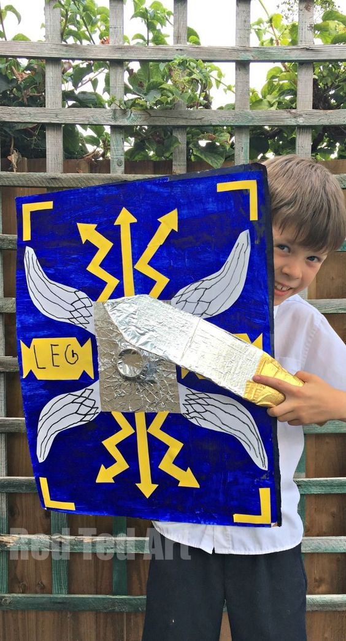

**Writing**

Watch this clip about the brothers Romulus and Remus. Write a play script about the story with the characters telling the story. (Maybe get members of your family to perform it once it is complete).

<https://www.youtube.com/watch?v=wA1D9wd29jI>

Create a fact file about Roman cities in Britain. Choose one city e.g. Bath and find out as much as you can about how and why the Romans created it and what they’ve left behind.

Write a letter/email to someone you haven’t spoken to in a while.(it could be Mrs Burnett!) Tell them about what’s going on and what you’ve been doing that you’ve really enjoyed.

**Maths**

A week’s worth of Mathletics revision will be ready to go from Monday morning.

TT rock stars, at least 10 minutes each day.

Topic

Investigate the Roman invasion of Britain. Create a timeline showing the spread of the Roman Empire from 800 BC to AD 305.

Discover how Romans created roads in Britain. Draw or print off a map of Britain and label as many Roman roads as you can.

Watch horrible Histories:

<https://www.youtube.com/watch?v=6dohpfFPi6U>

Create a poster, how rotten were the Romans really?

Find out about Roman soldiers. Draw or print a picture and label it. Research the why they were so successful; you might like to put on a performance after finding out about their marching and protective formations.

Science/DT

Using only recycled materials, create a ‘buggy’ to carry an egg. The ‘buggy’ must be able to safely carry an egg down a ramp. Think about everything you know about forces including friction. Others in your family might like to join in too – you could race them, see whose goes the furthest and whose is the safest. You don’t need to use an egg but if you do perhaps decorate it for Easter first.

**Spelling**

Have a go at these spelling games that focus on the Year 5 and 6 statutory word list. <https://www.spellzone.com/word_lists/games-10609.htm>

**French**

Use this fun website to revise topics you have visited this year in French. There are lessons to refresh your vocabulary knowledge, games and quizzes to take too!

<https://www.french-games.net/>

**Art**

Make a Roman mosaic. Choose an aspect of Roman history, for example a soldier, pottery, a shield, draw a rough outline then use small squares of paper to create a mosaic. Check out examples online.

You may also like to create a Roman shield using paints or coloured paper and a large piece of cardboard.

Reading

Challenge yourself to read at least once every day. Share as much of your reading with an adult at home as you can, and answer their questions about the storyline and the characters. You could write a review of a storybook you have read from your book bingo board. Alternatively, create a non-chronological report to summarise an information text you have enjoyed—this could be a book or an online article.

You can also listen to books for FREE at:

<https://www.worldofdavidwalliams.com/elevenses/>

<https://www.audible.co.uk/?source_code=M2M30DFT1Bk12108131902C5&&ipRedirectOverride=true>

RE

<https://www.youtube.com/watch?v=6SNr5zJFngg>

<https://www.youtube.com/watch?v=K01s7VxuDqo>

Watch the clips of the Prodigal Son and Jesus in the desert parables. Write a paragraph on each on what this teaches Jesus’ followers today about how they should live.

Retell one of them in a modern context, as a colourful comic strip.