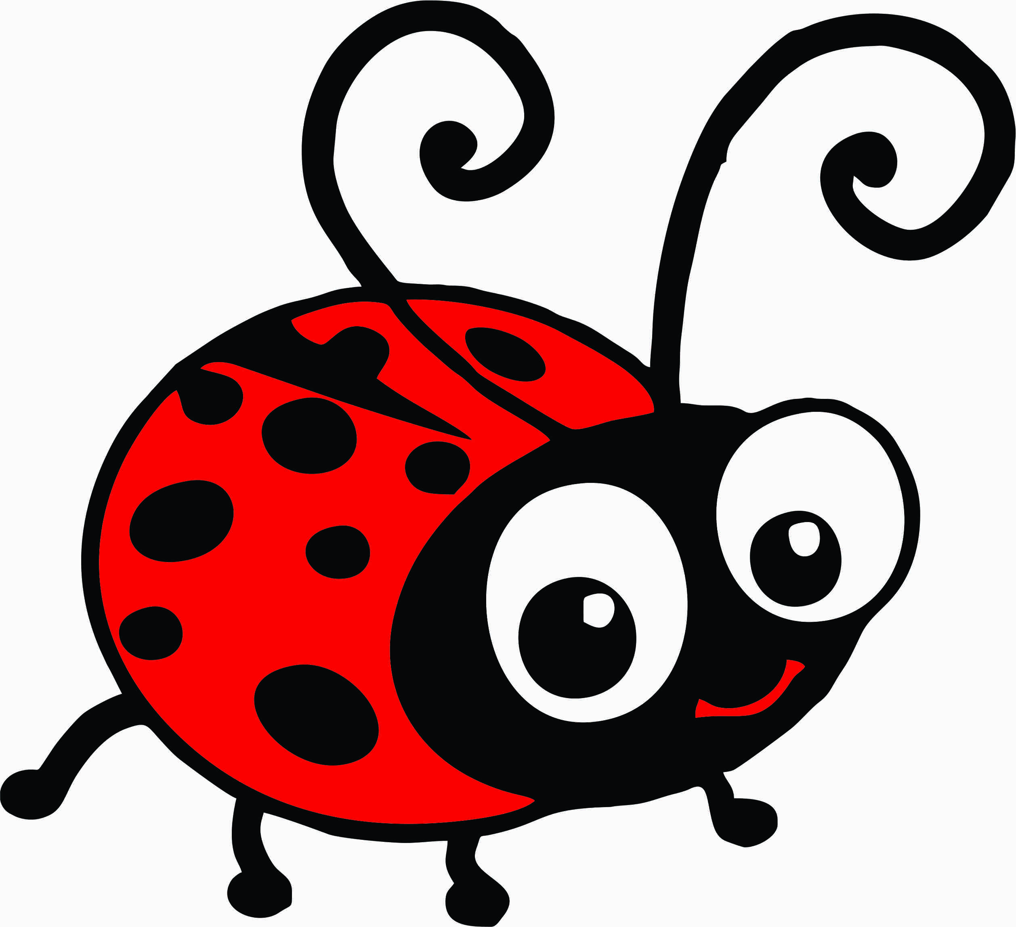

If the ladybird could talk, what would he say?